Расчетно-графическая работа №2

Фролова Алена, МХ-301

Вариант 8.

11 апреля 2017г.

Постановка задачи:

Решить задачу Коши: $y^{'}=-y+1; y\left(0\right)=-1.$ На отрезке [0,1] : $x_{0}=0;x_{1}=1$, с шагом h=0.1, h=0.05.  
Необходимо решить явным методом Эйлера, методом Рунге-Кутты четвертого порядка и методом Симпсона.

Точное решение: $y\left(x\right)=-2e^{-x}+1$

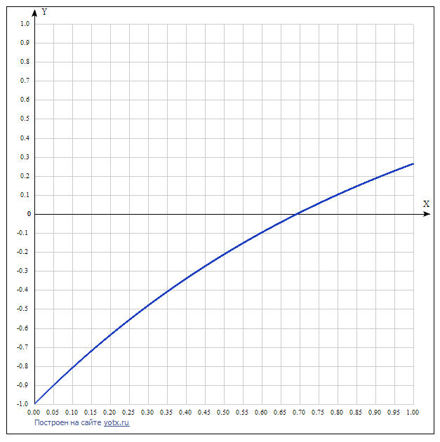

Решение явным методом Эйлера:

$$y_{n+1}=y_{n}+{y'}_{n}∙h \\ Для h=0.1 : y_{n+1}=y_{n}+{(-y}_{n}+1)∙0.1$$

|  |  |  |  |  |  |  |
| --- | --- | --- | --- | --- | --- | --- |
| $$x_{n}$$ | *0* | *0.1* | *0.2* | *0.3* | *0.4* | *0.5* |
| $$y_{n}$$ | *-1* | *-0.8* | *-0.62* | *-0.458* | *-0.3122* | *-0.18098* |
| $$x_{n}$$ | *0.6* | *0.7* | *0.8* | *0.9* | *1* |
| $$y_{n}$$ | *-0.062882* | *0.043406* | *0.139066* | *0.225159* | *0.302643* |

|  |  |  |  |  |  |  |  |
| --- | --- | --- | --- | --- | --- | --- | --- |
|  | *0* | *0.05* | *0.1* | *0.15* | *0.2* | *0.25* | *0.3* |
| $$y_{n}$$ | *-1* | *-0.9* | *-0.805* | *-0.71475* | *-0.629013* | *-0.547562* | *-0.470184* |
| $$x_{n}$$ | *0.35* | *0.4* | *0.45* | *0.5* | *0.55* | *0.6* | *0.65* |
| $$y_{n}$$ | *-0.396675* | *-0.32684* | *-0.26049* | *-0.197474* | *-0.1376* | *-0.08072* | *-0.026684* |
| $$x_{n}$$ | *0.7* | *0.75* | *0.8* | *0.85* | *0.9* | *0.95* | *1* |
| $$y_{n}$$ | *0.02465* | *0.073418* | *0.119747* | *0.163759* | *0.205571* | *0.245293* | *0.283028* |

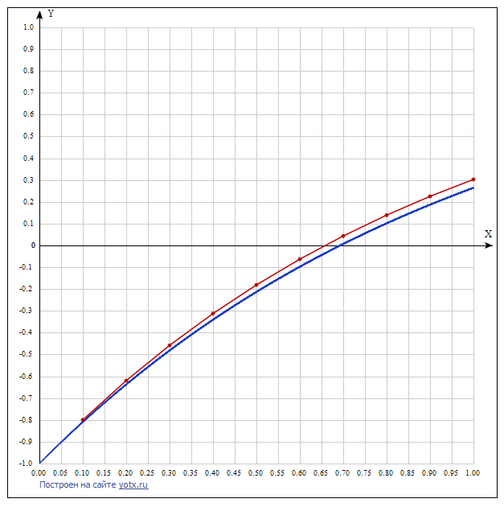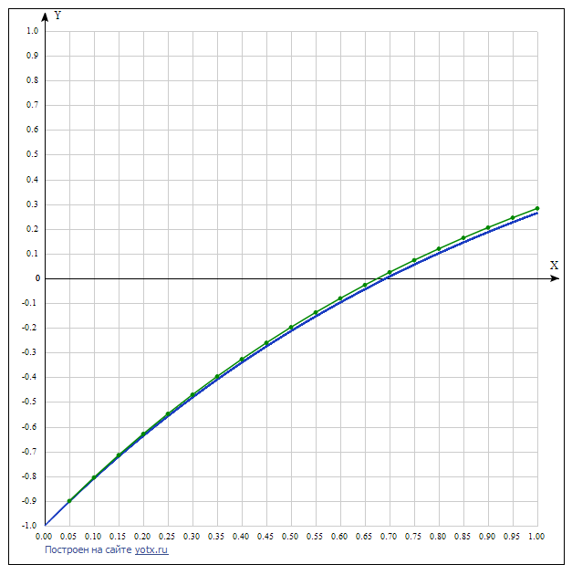

Решение методом Рунге-Кутты четвертого порядка:

$$y_{n+1}=y_{n}+\frac{h}{6}\left(K_{1}+{2K}_{2}+2K_{3}+K_{4}\right)$$

$$K_{1}=f\left(x_{n},y_{n}\right) \\ K_{2}=f\left(x_{n}+\frac{h}{2},y_{n}+\frac{h}{2}K_{1}\right) \\ K_{3}=f\left(x_{n}+\frac{h}{2},y_{n}+\frac{h}{2}K_{2}\right) \\ K_{4}=f(x_{n}+h,y_{n}+hK_{3})$$

$$Для h=0.1: { y}_{n+1}=y_{n}+\frac{0.1}{6}\left(K_{1}+{2K}_{2}+2K_{3}+K_{4}\right)$$

|  |  |  |  |  |  |  |
| --- | --- | --- | --- | --- | --- | --- |
| $$x_{n}$$ | *0* | *0.1* | *0.2* | *0.3* | *0.4* | *0.5* |
| $$y_{n}$$ | *-1* | *-0.809675* | *-0.637462* | *-0.481637* | *-0.340641* | *-0.213062* |
| $$x_{n}$$ | *0.6* | *0.7* | *0.8* | *0.9* | *1* |
| $$y_{n}$$ | *-0.097624* | *0.006829* | *0.101341* | *0.186860* | *0.264240* |

|  |  |  |  |  |  |  |  |
| --- | --- | --- | --- | --- | --- | --- | --- |
|  | *0* | *0.05* | *0.1* | *0.15* | *0.2* | *0.25* | *0.3* |
| $$y_{n}$$ | *-1* | *-0.902459* | *-0.809675* | *-0.721416* | *-0.637462* | *-0.557602* | *-0.481636* |
| $$x_{n}$$ | *0.35* | *0.4* | *0.45* | *0.5* | *0.55* | *0.6* | *0.65* |
| $$y_{n}$$ | *-0.409376* | *-0.34064* | *-0.275256* | *-0.213061* | *-0.1539* | *-0.097623* | *-0.044092* |
| $$x_{n}$$ | *0.7* | *0.75* | *0.8* | *0.85* | *0.9* | *0.95* | *1* |
| $$y_{n}$$ | *0.006829* | *0.055267* | *0.101342* | *0.14517* | *0.186861* | *0.226518* | *0.264241* |

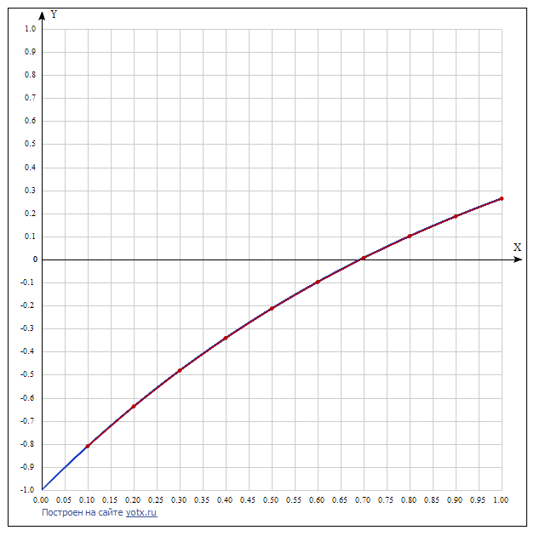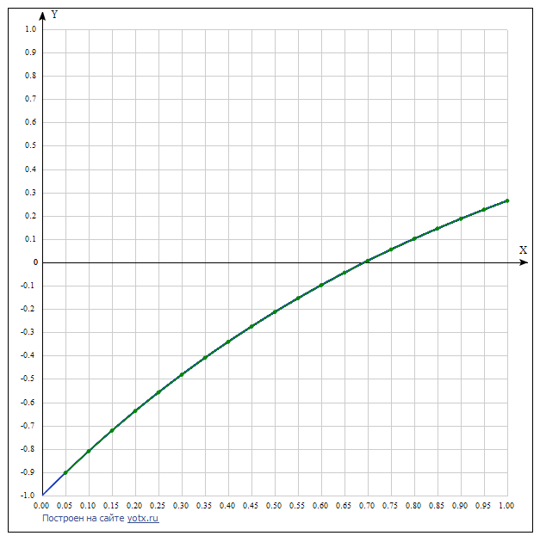

Решение методом Симпсона:

Будем проводить разгонку методом Рунге-Кутты четвертого порядка.

$$y_{n+1}=\frac{y_{n-1}+\frac{h}{3}∙\left(-y_{n-1}-{4y}_{n}+6\right)}{1+\frac{h}{3}}$$

$$Для h=0.1: y_{n+1}=\frac{y_{n-1}+\frac{0,1}{3}∙\left(-y_{n-1}-{4y}_{n}+6\right)}{1+\frac{0.1}{3}}$$

|  |  |  |  |  |  |  |
| --- | --- | --- | --- | --- | --- | --- |
| $$x_{n}$$ | *0* | *0.1* | *0.2* | *0.3* | *0.4* | *0.5* |
| $$y_{n}$$ | *-1* | *-0.809675* | *-0.637461* | *-0.481636* | *-0.34064* | *-0.213061* |
| $$x_{n}$$ | *0.6* | *0.7* | *0.8* | *0.9* | *1* |
| $$y_{n}$$ | *-0.097623* | *0.00683* | *0.101343* | *0.186861* | *0.264242* |

|  |  |  |  |  |  |  |  |
| --- | --- | --- | --- | --- | --- | --- | --- |
|  | *0* | *0.05* | *0.1* | *0.15* | *0.2* | *0.25* | *0.3* |
| $$y_{n}$$ | *-1* | *-0.902459* | *-0.809675* | *-0.721416* | *-0.637461* | *-0.557602* | *-0.481636* |
| $$x_{n}$$ | *0.35* | *0.4* | *0.45* | *0.5* | *0.55* | *0.6* | *0.65* |
| $$y_{n}$$ | *-0.409376* | *-0.34064* | *-0.275256* | *-0.213061* | *-0.1539* | *-0.097623* | *-0.044092* |
| $$x_{n}$$ | *0.7* | *0.75* | *0.8* | *0.85* | *0.9* | *0.95* | *1* |
| $$y_{n}$$ | *0.006829* | *0.055267* | *0.101342* | *0.14517* | *0.186861* | *0.226518* | *0.264241* |

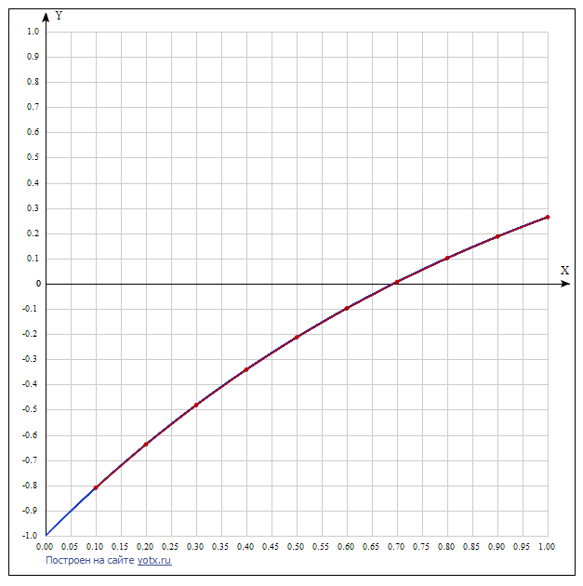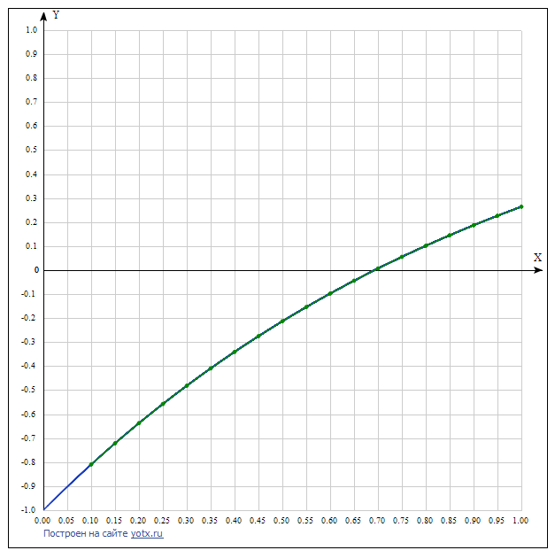

Вывод: как и ожидалось методы Рунге-Кутты четвертого порядка и Симпсона сходятся быстрее, так как при пересчете следующих значений учитываются предыдущие шаги.

Приложение:

**static** IEnumerable<(**double** x, **double** y)> ExplicitEulerMethod(**double** y0, **double**[] segment, **double** h)

{

**double** GetNextY(**double** y) => y + (-y + 1) * h;

var a = segment[0];

var b = segment[1];

var currentX = a;

var currentY = y0;

**while** (Math.Abs(currentX - b) > 1e-5)

{

currentX += h;

currentY = GetNextY(currentY);

**yield** return (currentX, currentY);

}

}

**static** IEnumerable<(**double** x, **double** y)> RungeKuttaMethods(**double** y0, **double**[] segment, **double** h)

{

**double** F(**double** y) => -y + 1;

var a = segment[0];

var b = segment[1];

var currentX = a;

var currentY = y0;

**while** (Math.Abs(currentX - b) > 1e-5)

{

var k1 = F(currentY);

var k2 = F(currentY + h / 2 * k1);

var k3 = F(currentY + h / 2 * k2);

var k4 = F(currentY + h * k3);

currentX += h;

currentY = currentY + h / 6 * (k1 + 2 * k2 + 2 * k3 + k4);

**yield** return (currentX, currentY);

}

}

**static** IEnumerable<(**double** x, **double** y)> SimpsonsRule(**double** y0, **double** y1, **double**[] segment, **double** h)

{

var a = segment[0];

var b = segment[1];

var currentX = a + h;

var previousY = y0;

var currentY = y1;

**while** (Math.Abs(currentX - b) > 1e-5)

{

currentX += h;

var y = (previousY + h / 3 * (-previousY - 4 * currentY + 6)) / (1 + h / 3);

previousY = currentY;

currentY = y;

**yield** return (currentX, currentY);

}

}